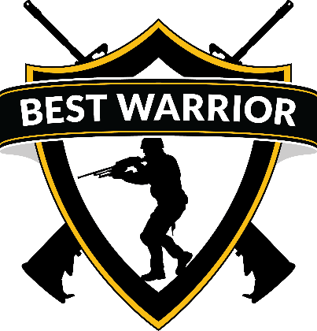

2019 BWC PACKING LIST
UNIFORMS: ARMY SERVICE UNIFORM WITH ALL AUTHORIZED AWARDS AND
DECORATIONS.

THE IMPROVED PHYSICAL FITNESS UNIFORM (IPFU) WILL BE WORN FOR THE APFT. BRING JACKET, RUNNING SHOES, BLACK (WINTER TOP) AND BOTTOM, BLACK LEATHER GLOVES, REFLECTOR BELT AND CAP SYNTHETIC MICRO FLEECE BLACK "WATCH CAP."

THE ARMY OPERATIONAL CAMOUFLAGE PATTERN (OCP) WILL BE WORN FOR THE PERFORMANCE TESTING.

ENSURE EACH COMPETITOR TRAVELS WITH THE FOLLOWING TA50 ITEMS:

- UNIFORM OCP TOP & BOTTOM (x2)
- UNDERSHIRT: SAND, TAN, OR FOLIAGE (4EA)
- SOCKS: TAN, GREEN, OR BLACK (4 PR)
- IMPROVED OUTER TACTICAL VEST (IOTV) OR ISSUED PLATE CARRIER COMPLETE W/GROIN PROTECTOR AND SAPI PLATES (2) EA.
- MODULAR LIGHTWEIGHT LOAD-CARRYING EQUIPMENT (MOLLE)/ LCE/ LBV/ TAP.
- THREE 2-MAGAZINE AMMO POUCHS, 2-GRENADE POUCHES, INDIVIDUAL FIRST AID KIT (IFAK) COMPLETE WITH NO OUT DATED ITEMS.
- ASSAULT PACK.
- MOLLE RUCK SACK.
- WET WEATHER BAG.
- WET WEATHER BOOTS.
- WET WEATHER TOP AND BOTTOM.
- KNEE AND ELBOW PADS.
- COMBAT GLOVES APEL APPROVED.
- BALLISTIC EYE PROTECTION WITH BOTH CLEAR & SMOKED LENSES.
- TWO 1QT CANTEENS W/CANTEEN CARRIERS AND A CAMEL BACK.
- ADVANCED COMBAT HELMET (ACH) W/PADS AND COVER.
- JOINT SERVICE LIGHTWEIGHT INTEGRATED SUIT TECHNOLOGY (JSLIST) W/GLOVES.
- M40/M42 PROTECTIVE MASK.
- MODULAR SLEEP SYSTEM.
- LENSATIC COMPASS
- PROTRACTOR
- MAP PENS
- BASIC WATCH (NON-SMART)
- SOURCE OF WHITE LIGHT WITH RED LENS CAPABILITY (HEADLAMP OK)

OPTIONAL ITEMS
ARMY COMBAT SHIRT; COMBAT UNIFORM TROUSERS; 2ND PAIR OF COMBAT BOOTS: TAN OR COYOTE

